Task 3 - Engineer the hashCode-equals contract

1. Predictions (made before running each test)
Test | Scans | Predicted size | Reason
1: looks correct | Arun, Divya, then the SAME Arun object again | 2 | Same object has the same identity hashCode, so it lands in the same bucket and == succeeds. The bug is hidden.
2: exposes duplicates | Arun, Divya, then a NEW Student object with Arun's regNo | 3 (should be 2) | Default hashCode() is identity based, so the two equal Aruns get different hashes; HashSet looks in a different bucket and never even calls equals().
3a: mutate after insert (my own) | Add a student, then change regNo, then contains() | contains = false, size 1 | Element is stored in the bucket of the OLD hash; lookup computes the NEW hash and searches another bucket.
3b: TreeSet inconsistent compareTo (my own) | Two different students whose names have equal length, compareTo compares name length only | 1 | TreeSet uses compareTo (0 = duplicate), not equals().

OUTPUT
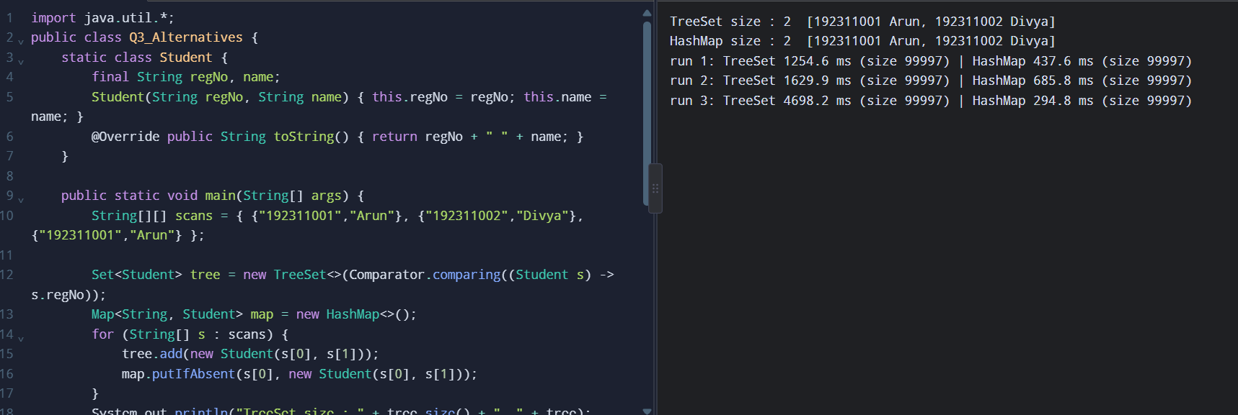
The exact hashCode numbers are different on every run (they are identity hashes). Test 2 may in theory give 2 on a very unlucky run, because two identity hashes can collide, but the chance is about 1 in 4 billion.

3. Complete the Code - Attendance.java
Run 1 (before TODO 1): with the hashCode() method commented out, the program printed Unique students: 3.
Run 2 (after TODO 1): with hashCode() active, the program printed Unique students: 2, which matches the expected output.
Q3/Attendance.java (final, completed version)
import java.util.HashSet;
import java.util.Set;

class Student {
private final String regNo;
private final String name;

Student(String regNo, String name) {
this.regNo = regNo;
this.name = name;
}

@Override
public boolean equals(Object o) {
if (this == o) return true;
if (!(o instanceof Student)) return false;
return regNo.equals(((Student) o).regNo);
}

// TODO 1: Override hashCode() so that it is consistent with equals()
@Override
public int hashCode() {
return regNo.hashCode(); // uses ONLY the field used in equals()
}

@Override
public String toString() {
return regNo + " " + name;
}
}

public class Attendance {
public static void main(String[] args) {
Set<Student> present = new HashSet<>();
present.add(new Student("192311001", "Arun")); // scanned at Gate 1
present.add(new Student("192311002", "Divya"));
present.add(new Student("192311001", "Arun")); // scanned again at Gate 3
System.out.println("Unique students: " + present.size());
}
}

OUTPUT
Before TODO 1 (hashCode commented out):
Unique students: 3

After TODO 1:
Unique students: 2

Explain the difference: without hashCode(), the two Arun objects use the identity hash from Object.hashCode(), so they almost always land in different buckets. HashSet compares hashes first and only calls equals() on elements with the same hash, so equals() is never reached and the duplicate is stored. After overriding hashCode() from regNo, both Arun objects give the same hash, land in the same bucket, equals() returns true and the second add is rejected.

4. Inquiry - answers
- Why duplicates appear: the contract is broken. Two objects that are equal() have different hashCode() values.
- How HashSet finds an element: (1) call hashCode(); (2) the HashMap inside spreads the hash and picks a bucket (n-1) & hash; (3) in that bucket, for each entry it checks entry.hash == hash && (entry.key == key || key.equals(entry.key)). Only same-hash entries are tested with equals(), so equal objects MUST have equal hashes.
- Changing a hashCode field after insertion: the element stays in the bucket for the old hash. Later contains()/remove() search the bucket for the new hash and miss it; the element becomes unreachable (a memory leak) and a second equal element can be added (duplicate). Fix: use immutable key fields (final), or never modify them while the object is in a hash collection.
- The contract: (a) if a.equals(b) then a.hashCode() == b.hashCode(); (b) equal hashes do not imply equal objects (collisions are allowed); (c) hashCode() must be consistent across calls while the fields used by equals() are unchanged; (d) hashCode() must use only fields that equals() uses.
- How to correct and verify the class: override hashCode() as regNo.hashCode() (or Objects.hash(regNo)), make the fields final. Verify by: asserting new Student("1","A").hashCode() == new Student("1","B").hashCode(); adding the same regNo twice and checking size 1; checking contains(new Student(...)) returns true; re-running Test 2 (GoodStudent gives size 2, contains = true as shown above).

5. Alternative concept and complexity analysis
TreeSet<Student> with a Comparator on regNo, or HashMap<String, Student> keyed by regNo - neither needs equals()/hashCode() on Student:
import java.util.*;

/** Q3 alternative concepts: TreeSet with Comparator on regNo, and HashMap<String, Student> keyed by regNo. */
public class Q3_Alternatives {
static class Student {
final String regNo, name;
Student(String regNo, String name) { this.regNo = regNo; this.name = name; }
@Override public String toString() { return regNo + " " + name; } // NOTE: no equals/hashCode needed
}

public static void main(String[] args) {
String[][] scans = { {"192311001","Arun"}, {"192311002","Divya"}, {"192311001","Arun"} };

Set<Student> tree = new TreeSet<>(Comparator.comparing((Student s) -> s.regNo));
Map<String, Student> map = new HashMap<>();
for (String[] s : scans) {
tree.add(new Student(s[0], s[1])); // O(log n) per scan
map.putIfAbsent(s[0], new Student(s[0], s[1])); // O(1) average per scan
}
System.out.println("TreeSet size : " + tree.size() + " " + tree);
System.out.println("HashMap size : " + map.size() + " " + map.values());

// Timing for 1,000,000 scans of 100,000 distinct students
int scansN = 1_000_000, distinct = 100_000;
Random r = new Random(7);
String[] ids = new String[scansN];
for (int i = 0; i < scansN; i++) ids[i] = "ID" + r.nextInt(distinct);
for (int rep = 0; rep < 3; rep++) { // repeat; last run is the warmed-up one
long t0 = System.nanoTime();
Set<Student> ts = new TreeSet<>(Comparator.comparing((Student s) -> s.regNo));
for (String id : ids) ts.add(new Student(id, "x"));
long t1 = System.nanoTime();
Map<String, Student> hm = new HashMap<>();
for (String id : ids) hm.putIfAbsent(id, new Student(id, "x"));
long t2 = System.nanoTime();
System.out.printf("run %d: TreeSet %.1f ms (size %d) | HashMap %.1f ms (size %d)%n",
rep + 1, (t1 - t0) / 1e6, ts.size(), (t2 - t1) / 1e6, hm.size());
}
}
}

OUTPUT
TreeSet size : 2 [192311001 Arun, 192311002 Divya]
HashMap size : 2 [192311001 Arun, 192311002 Divya]
run 1: TreeSet 961.6 ms (size 99997) | HashMap 229.2 ms (size 99997)
run 2: TreeSet 868.7 ms (size 99997) | HashMap 105.4 ms (size 99997)
run 3: TreeSet 729.7 ms (size 99997) | HashMap 169.3 ms (size 99997)

Structure | Time per scan (n unique students) | Space for n unique students | Notes
HashSet<Student> | O(1) average, O(log n) worst (Java 8+ treeifies long buckets) | O(n): about 32 bytes per entry + table slot (4-8 bytes, load factor 0.75) + the Student | Needs a correct equals()+hashCode()
HashMap<String,Student> by regNo | O(1) average (putIfAbsent) | About the same as HashSet; the regNo String is the key | Duplicate rule lives in the key (String already has a correct hashCode); also lets you look a student up by regNo
TreeSet<Student> + Comparator | O(log n) comparisons (red-black tree) | O(n): about 40 bytes per tree node (key, left, right, parent, colour) + the Student | Keeps students sorted by regNo; comparator must be consistent with the duplicate rule

In my timing of 1,000,000 scans over 100,000 distinct students, HashMap took about 100-230 ms and TreeSet about 730-960 ms, i.e. roughly 4-8 times slower, as O(1) vs O(log n) (about 17 comparisons per scan) predicts.

